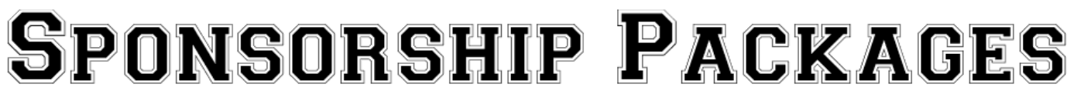
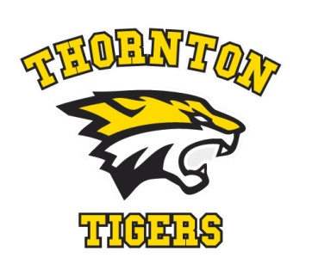
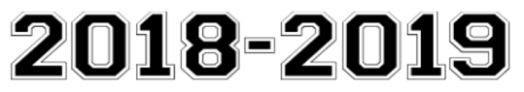

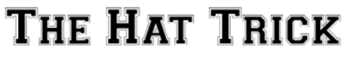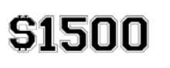
- Home Jersey Sponsorship- your company name on the back of each jersey.
- Away Jersey Sponsorship - your company name on the back of each jersey.
- Sponsor sign in the Thornton Arena.
- Logo or Company Name on the website.
- Hole Sponsor Sign in the TMHA tournament September 15th 2018.
- Foursome of golf in the TMHA tournament September 15th 2018.
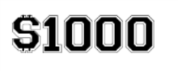
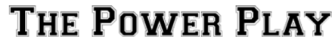

- Home Jersey Sponsorship- your company name on the back of each jersey.
- Away Jersey Sponsorship - your company name on the back of each jersey.
- Sponsor sign in the Thornton Arena.
- Logo or Company Name on the website.
- Hole Sponsor Sign in the TMHA tournament September 15th 2018.
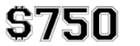
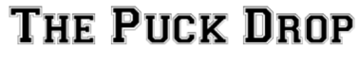
(SOLD OUT)
- Game pucks for the season with your company name/logo printed on them to be used by the organization.
- Sponsor sign in the Thornton Arena.
- Logo or Company Name on the website.
- Hole Sponsor Sign in the TMHA tournament September 15th 2018.
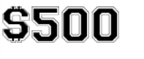
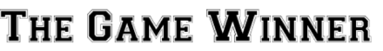
- Away Jersey Sponsorship - your company name on the back of each jersey.
- Sponsor sign in the Thornton Arena.
- Logo or Company Name on the website.
- Hole Sponsor Sign in the TMHA tournament September 15th 2018.
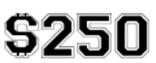
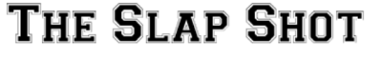
- Sponsor sign in the Thornton Arena.
- Logo or Company Name on the website.
- Hole Sponsor Sign in the TMHA tournament September 15th 2018

